huber_loss_bidirectional_gru_model.h5

MAE: 2313.730286216393

RMSE: 3042.7498545687617

R²: 0.9844944754922059

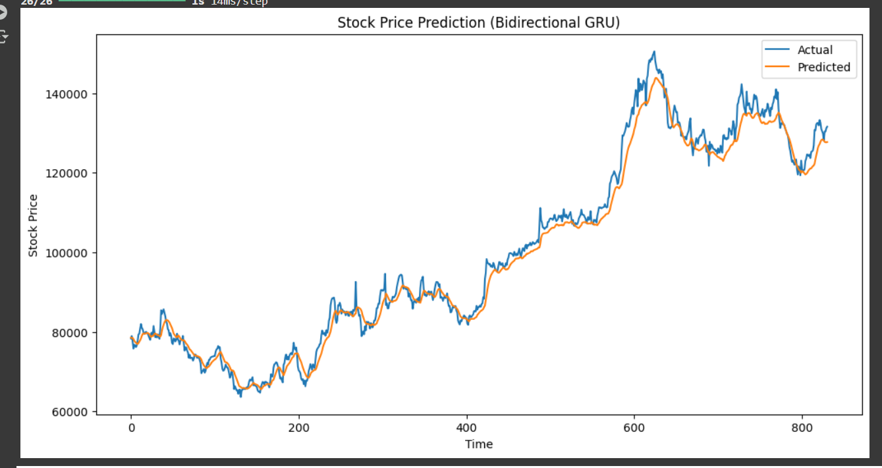

This below model saved as “bidirectional_gru_model_adamw_sma_21_10.keras”

This MAE: 1730.8850402077296

This RMSE: 2317.621369196922

This R²: 0.9910042177555352

